

Youth Worker CPD Resources Pack

RSPB have worked in partnership with Seven Lochs for almost 7 years, and it became apparent that there was an incredible number of greenspaces in the area. There is a lot of grey infrastructure which can make outdoor sessions feel like they are out of reach or that you must travel to access greenspaces. However, it's crucial that you feel like you can access local greenspaces, so that you can lead by example with your young people. Pick areas you feel comfortable in to begin with, I.e. if you live in Coatbridge, you may feel most confident going to Drumpellier or a local park.

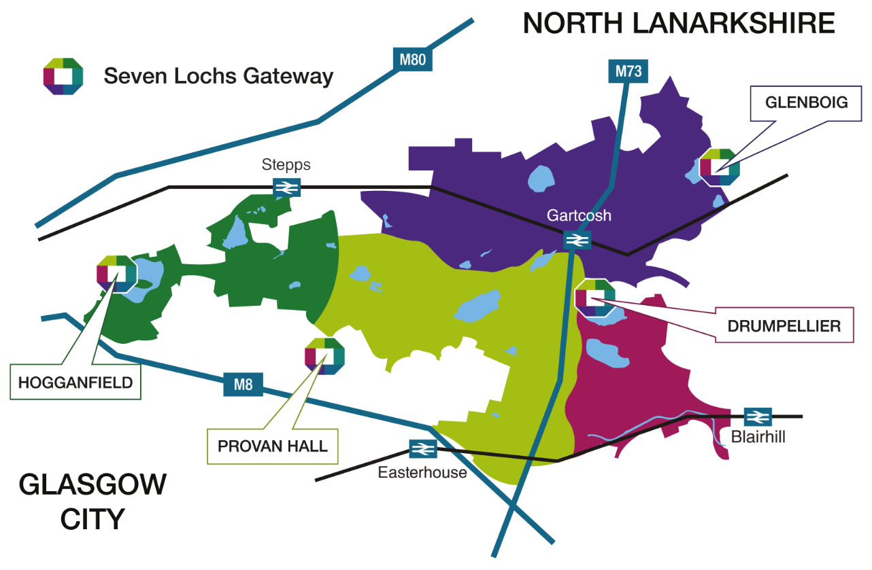

The great thing about the Seven Lochs area, is the transport links, so it can be easier to travel to various greenspaces. Also, Hogganfield, Provan Hall, and Drumpellier are parks which experience high footfall, which can make it safer for you and your young people. When beginning your outdoor activities journey, I would suggest starting in busier greenspaces that you feel safe in and taking it from there. Also, it's important to think of the area you are using, because depending on where the young people live, they may not feel safe in different areas. Prior to going out, it would be worthwhile having a discussion with your group, then you can get a feel of their experiences in nature, where they would feel safe and what they would like doing.

**Before you head out with your young people, it is important to recognise barriers that could prevent/discourage them to spend time outdoors in nature:**

|  |  |
| --- | --- |
| Barriers/Risks | Solutions |
| Hazards & accidents – hole, branches & falls | Research the best areas – Greenspace Scotland. Contact local council. Risk Assessments (RAs). |
| Weather | Do RA well in advance: Ensure time for a repeat as close to session as possible & have a back-up plan |
| Boundaries | Set clear boundaries of the space you will be using |
| Knowledge of the local area | Get to know the space yourself, connect with local community groups |
| Traffic Issues | Avoid traffic where possible, brief the group beforehand and supervise |
| Dogs, bicycles & other people | Brief the group on how to interact with distractions beforehand. Maintain supervision |
| Biting & stinging nettles | Inform the group, prevention is key, carry a first aid kit & be aware of allergies |
| Time constraints | Prepare with the group beforehand (e.g making a map of the area, walking there). Think local |
| Lack of staff support | Know your child-adult ratio, key staff for outdoor learning, help from parents/guardians, possibly work/collaborate with other youth workers. Utilise trusted organisations support (RSPBB, TCV, John Muir Trust, etc) |
| Appropriate clothing | Check grants for clothing (GFL), organisation budgets, prepare for bad weather, plan ahead & give notice to parents/guardians |
| Losing control of the group | Set engaging tasks/activities, be flexible in your approach |
| Limiting mischief | Stimulate creative active learning and, when possible, let their interests lead the session |
| Ensuring safety | RAs, your attitude often defines theirs |

**Activating the senses & exploring**

Utilising all 5 senses is a wonderful way to engage with nature. These can be a new way of exploring your surroundings and discussing how we fit in with nature and wildlife. For example, many of your sessions may take place in urban settings, and you can get the group to close their eyes and listen. What can they hear? Are there birds singing? What other noises do they hear? This is a fantastic way to ground the group and getting them to take stock of their surroundings.

Another activity that you can do is to get the group to close their eyes, **listen** to the surroundings and draw what they can hear. This could abstract drawings of the sounds they hear, writing how it makes them feel and so on, but the focus is for them to be creative. Therefore, without relying on site, they can connect with nature in an alternative way.

Using the **sight**, you can engage with the surroundings, but in a way that the group will notice more details. The camera game is an excellent example of this, split the group into pairs and get them to find a space. The premise of the game is that one person will act as the ‘camera’ and the other will be the person act as the picture ‘capturer’

1. The ‘camera’ will stand with their eyes closed, and the ‘capturer’ will stand behind them, placing their hands on the ‘camera’s shoulders’
2. When they both feel ready, the ‘capturer’ will gently squeeze the ‘camera’s’ shoulders, which will indicate that the ‘camera’ should open their eyes for 5 seconds and take in the landscape in front of them
3. After this, the pair should switch places and repeat.
4. After they have both acted as the camera, get them to draw what they seen and compare.

The aim of this is for the group to take more scope of their surroundings and to show how differently we connect with nature. Thus, reinforcing that there is not any 1 way to connect with the natural world.

Another activity is:

1. Get the group to look at a space, preferably with a variation of habitats
2. Get them to turn away and you can add 10-15 miscellaneous items to the space
3. Once they have turned back round, the aim is for them to point out the added items

This is a wonderful way for the group to take notice and focus on the minute details.

Utilising **touch** when exploring green spaces is another fantastic way for the group to connect with nature. This could be anything from leaves, to flowers, bark and so on. Here is a great activity that utilises touch:

1. Pick a wooded area with numerous trees and split the group into pairs
2. Once they are in pairs, 1 person will close their eyes and the other will guide them, with their hands on their shoulders, to a tree.
3. Once they are at the tree, the person with their eyes closed will use their touch to explore the tree, feeling for grooves, individual markers and so on.
4. After they have inspected the tree, the person leading should spin them in a circle for a few times and then lead them back to the starting position.
5. Once everyone has completed this, the people who had their eyes closed should go to find their tree and explain why their thought process behind choosing a particular tree.
6. The pair should swap places and repeat.

The aim of this game is for the group to use their touch to really feel the tree and recognise patterns, bums, if there is lichen (a moss) on it and so on. Once again, we are getting the group to focus on smaller details while connecting with nature.

Using **smell**, can be quite a simple activity. For example, smelling the flowers that are in bloom, discussing the variations of smells (esp in an urban environment) and how it makes them feel. How many different things can they smell? Do they know what they are?

Using **taste** can be quite different, unless you are quite confident in identifying various berries etc, I would avoid this. But, if you have a foraging background/knowledge, then this is something you could definitely include in your session.

**Health & Wellbeing**

It is no surprise that spending time outside can help with a person’s health and wellbeing, but in such a digital age it can be difficult to get this message across. It is beneficial for your groups to slow down, take their time and enjoy nature in any way that they can (that is safe). Thus, having a good variation of activities can make being outdoors more enjoyable and fun.

For example, if any of the group are interested in taking pictures, please encourage them to do so- set them tasks to get pictures that include certain colours and so on. Also, if they get clear images of plants and wildlife, they can upload them to iNaturalist (an ID app) and get to know the species in their area.

Here are some links to great games that you can play, they all focus on slowing down and enjoying the environment:

<https://dramaresource.com/grandmas-footsteps/>

<https://mothernatured.com/nature-play/outdoor-nature-games-for-children/>

<https://www.mentalhealth.org.uk/explore-mental-health/publications/thriving-nature>

<https://www.twinkl.co.uk/blog/10-of-the-best-outdoor-mental-health-activities-for-children>

These are just some of the activities that you can do, but it is important to recognise what works with your group and run with it!

**A Tiny Creature’s World**

Minibeast Safari, bug hunts, looking for beasties – these are only some phrases that we use to describe looking for bugs/beasties/insects/spiders. So, before you even begin to explain a bug hunt, its useful to figure out what term the group use to refer to invertebrates (the collective term for bugs). This helps to simplify that task, and to create a sense of collective understanding of what bugs are, and the names of them. Also, it is helpful to explain what an invertebrate is, they are creatures that do not have spines. I would usually get the group to list what invertebrates they know, again this may or may not work, depending on the age range of your group.

When conducting a bug hunt, make sure you pick an area that has a combination of trees, hedges, bushes and grass. Having this variety, means that the group can split up and look at different habitats, thus providing you with more chance of finding invertebrates. Also, the weather can play a huge role in finding bugs, when the weather is colder, usually you do not find as many. Whereas, if the weather is warmer and more humid, you will find more insects, so this is something to consider when planning your schedule.

In the 7 lochs Education Pack (page 1-4) you will find step-by-step instructions on how to do a bug hunt, and there are also ID spotting sheets. If you find

**Eco Crafts**

There are many natural resources that you can utilise for an eco-crafts session. However, it is important to have some basic supplies such as paper, pencils, pens and crayons if necessary. Having these basic supplies, would mean that you can adapt them to the activity you are doing, and can be used indoors and outdoors. Also, this is if your department have the budget for these supplies, but usually most people have these items lying around work or in their home.

When you are approaching an eco-craft session, it is helpful to question the interest and teaching level of the class and making it accessible/age appropriate. For example, older groups may not be interested in tree bark rubbing, but how could you make this more challenging for them? Could you get them to trace the groves of the tree or do an abstract drawing with the bark rubbing.

The aim of session is to get the young people creative outdoors, and engaging with nature in a more subtle way that they may feel comfortable with. Some ideas that you can use are:

* Drawing a landscape picture
* Flower pressing
* Tree bark rubbing
* Making an abstract picture about the sounds that they can hear
* Rock painting
* Make a bee home
* Make seed creatures
* Apple bird feeders

<https://www.weareteachers.com/earth-day-crafts-classroom-activities/>

<https://rspb.org.uk/fun-and-learning/for-kids/games-and-activities/>

These are only some of the ideas that you can do with your group, but these can be altered, adapted, and expanded to suit your needs. The main thing is that you and your group are having fun, whilst spending time outdoors in a green space.

**Conclusion**

We hope that this pack is useful and will provide loads of tips when accessing nature with your young people. It's great to use this in combination with the Seven Lochs Education pack, which will also be sent to you in a separate document. We will also attach a document with useful links to aid your outdoor activities and we would recommend accessing the UNP youth worker toolkit which is linked below. We hope this helps you but remember having fun and connecting with nature is the aim, no matter how you do it!

UNP Youth Worker toolkit: <https://www.nhm.ac.uk/take-part/youth-worker-toolkit.html>