Bingo Questions…

Read out from the below questions, ensuring that you alternate the order that you read for each game.

The day to day condition of the atmosphere… Weather

The average weather in a place… Climate

A person who studies the weather….Meteorologist

An instrument that measures air pressure….Barometer

An instrument that measures wind speed….Anemometer

The amount of sky that is covered by cloud…Cloud cover

Fluffy clouds forming low in the sky…Cumulus clouds

Big blankets of dull cloud completely covering the sky…Stratus clouds

Thin wispy clouds over 6km high…Cirrus clouds

Rain caused by the sun heating the ground….Convectional rainfall

Rain caused by wind pushing clouds over mountains….Relief rainfall

Rain caused by warm air rising over cold air….Frontal rainfall

The weight of the air pushing down on the earth….Air pressure

Air moves around the earth in huge block of air….Air mass

The leading edge of an air mass….Front

A large swirl of cloud that passes over the UK made up of a cold front chasing a warm front….Depression

How far a place is north or south of the equator….Latitude

The direction the wind blows in the most often….Prevailing wind

The study of the weather….Meteorology

An instrument used to measure how much rain has fallen….Rain gauge

An instrument used to measure the wind direction….Weather vane

A symbol to show a warm front….

A symbol to show a cold front…. 

A symbol to show an occluded front…..

A symbol to show sun and possible snow…..

A symbol to show sun and possible rain…..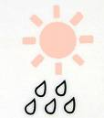

A symbol to show sunshine and warm weather…..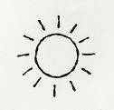

A symbol to show cloud and some sun…. 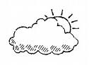

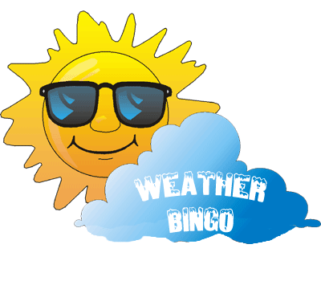

Weather | Barometer | Anemometer | Cirrus clouds | Relief rainfall
Frontal rainfall | Stratus clouds | Climate | Front | Air mass
Convectional rainfall | Meteorologist | Cloud cover | Air pressure | Depression

Prevailing wind | Latitude | Front | Depression | Relief rainfall
Air mass | Weather | Climate | Barometer | Cloud cover
Cumulus cloud | Stratus cloud | Cirrus cloud | Convectional rainfall

 |  | Air mass | Frontal rainfall | Air mass
Front | Cloud cover | Prevailing wind | Meteorology | Meteorologist
Weather | Stratus clouds | Anemometer | Rain gauge | Weather vane

 | Weather vane |  | Anemometer | Meteorologist
Prevailing wind |  | Relief rainfall | Convectional rainfall
Barometer |  | Depression | Anemometer | Front

Air mass | Latitude | Stratus clouds | Cumulus cloud
 |  |  | Weather vane | Weather
Anemometer | Meteorologist | Prevailing wind | Rain gauge

 | Prevailing wind |  | Meteorology | Air pressure
 | Depression | Relief rainfall | Barometer
Anemometer | Convectional rainfall | Air mass | Weather vane | Front

Front | Rain gauge | Meteorology | Anemometer | Prevailing wind
 |  | Convectional rainfall |  | Weather vane
Meteorologist | Barometer | Weather |  | Stratus clouds

Stratus clouds |  | Anemometer
Air pressure | Air mass | Front | Frontal rainfall
 | Weather vane | Cumulus cloud | Latitude | Weather

Meteorology |  | Front | Depression | Rain gauge
Convectional rainfall |  |  |  | Weather vane
Prevailing wind | Relief rainfall | Stratus clouds | Anemometer | Barometer

Anemometer | Cumulus cloud | Frontal rainfall | Stratus clouds | Prevailing wind
 | Front | Rain gauge | Weather | Air mass
Weather vane | Meteorology |  |  | Air pressure

Air pressure | Stratus clouds | Frontal rainfall |  | Latitude
Front | Weather vane |  | Cumulus cloud | Barometer
 | Anemometer |  | Meteorology | Relief rainfall

 | Latitude | Cumulus cloud | Meteorologist | Stratus clouds
Rain gauge | Anemometer |  |  | Weather vane
Front | Depression | Air mass | Weather

Weather vane | Latitude |  | Air pressure
Anemometer | Stratus clouds |  | Cumulus cloud | Front
Weather |  | Rain gauge | Barometer | Meteorology

Cumulus cloud | Relief rainfall | Latitude |  | Convectional rainfall
Depression |  |  | Weather vane | Anemometer
Meteorology | Air mass | Meteorologist |  | Air pressure

